Name

Mathematics Advanced Year 11
Equations

Book 1 |  | Version: 261020  Feedback:  https://MrDingMaths.com
Contents
Syllabus Content 2
Learning Intention 3

Syllabus Content
MAV-11-01 applies algebraic techniques and the laws of indices and surds to manipulate expressions and solve problems
Algebraic techniques
- Use index laws to simplify expressions and solve problems involving positive, negative, zero or fractional indices
- Expand, factorise and simplify algebraic expressions
- Simplify expressions involving algebraic fractions
- Expand and simplify expressions involving surds
- Identify the conjugate of $\sqrt{a}±\sqrt{b}$, and rationalise the denominators of expressions of the form $\frac{a}{\sqrt{b}±\sqrt{c}}$ and $\frac{\sqrt{a}±\sqrt{d}}{\sqrt{b}±\sqrt{c}}$, where $a$, $b$, $c$ and $d$ are positive rational numbers
- Solve quadratic equations $ax^{2}+bx+c=0$ by factorisation, completing the square and using the quadratic formula $x=\frac{-b±\sqrt{b^{2}-4ac}}{2a}$ where $a$, $b$ and $c$ are real numbers and $a≠0$
- Define the discriminant as $Δ=b^{2}-4ac$ and use it to solve problems involving the number of real roots of a quadratic equation and determine the conditions for roots to be equal, distinct, real or rational

Multistep Linear Equations

- Using Formulas to Find Unknowns
We use formulas to find the value of any unknown, if we know all other quantities.
- Write the formula.
- Substitute given values.
- Solve to find the unknown.

- Example Solve equations after substituting into a formula
$y=2x+7$.  Find $x$ when $y=29$.  1. $y=2x+7$  2. $29=2x+7$  3. $22=2x$  $11=x$ | $$A=\left(n-1\right)d$$  Find $n$ when $A=40, d=5$  1. $A=\left(n-1\right)d$  2. $40=\left(n-1\right)\left(5\right)$  3. $8=n-1$  $9=n$

- Guided Practice
- $A=lw$.  Find $l$ if $A=720$ and $w=8$ | - $y=2x-5$  Find $x$ when $y=20$
- $T=a\left(n+1\right)$  Find $n$ if $T=55, a=11$ | - $A=P{\left(1+r\right)}^{n}$  Find $P$ if $A=196, r=0.4, n=2$

- Equations involving Algebraic Fractions: Monomial Numerator
- To solve equations involving two algebraic fractions:
- Rewrite each algebraic fraction with their common denominator.
- Simplify by adding or subtracting the fractions.
- Solve.

- Example Solve equations involving two fractions and monomial numerators
$$\frac{x}{2}+\frac{x}{5}=3$$1. Denominators $\frac{5x}{10}$ $+$ $\frac{2x}{10}$ $=3$2. Simplify $\frac{7x}{10}$ $=3$3. Solve $×10=×10$ $7x=30$ $÷7=÷7$ $x=$ $\frac{30}{7}$

- Guided Practice
Solve these equations.
- $\frac{x}{5}+\frac{2x}{5}$ $=18$  $$x=30$$ | - $\frac{x}{5}+\frac{x}{6}$ $=22$  $$\frac{}{30}+\frac{}{30}=22$$  $$x=60$$
- $\frac{2x}{3}+\frac{5x}{4}$ $=46$  $$x=24$$ | - $\frac{x}{3}-\frac{x}{2}$ $=10$  $x=-60$

- Equations involving Algebraic Fractions: Binomial Numerator
- To solve equations involving two algebraic fractions with binomial numerators:
- Rewrite each algebraic fraction with their common denominator.
If the fraction has a binomial numerator, you must multiply each term.
- Simplify by adding or subtracting the fractions.
- Solve.

- Example Solve equations involving two fractions and binomial numerators
$$\frac{x-1}{2}+\frac{x+2}{5}=2$$
1. Denominators $\frac{5\left(x-1\right)}{10}$ $+$ $\frac{2\left(x+2\right)}{10}$ $=2$2. Simplify $\frac{5x-5+2x+4}{10}$ $=2$ $\frac{7x-1}{10}$ $=2$3. Solve $×10 ×10$ $7x-1=20$ $7x=21$ $x=3$

- Guided Practice
Solve these equations.
- $\frac{x+3}{3}+\frac{x-4}{2}$ $=4$  $$\frac{2(x+3)}{6}+\frac{3(x-4)}{6}=4$$  $$x=6$$ | - $\frac{x-1}{3}=\frac{x}{4}$  $$x=4$$
- $\frac{x}{2}-\frac{2x+1}{3}$ $=2$  $$x=-14$$ | - $\frac{x+2}{3}-\frac{2x-1}{2}$ $=4$  $$x=-\frac{17}{4}$$

- Cross Multiplying
- Cross multiplying is a shortcut.
- Only use this shortcut when $Fraction=Fraction$

$$\frac{a}{b}=\frac{c}{d}$$
$$\frac{a}{b}=\frac{c}{d}$$
$$ad=bc$$

- Example Solve equations involving fractions by cross multiplying
Common denominator method | Cross multiplying method
$$\frac{x-1}{3}=\frac{x}{4} \\ \frac{4\left(x-1\right)}{12}=\frac{3x}{12} \\ ×12=×12 \\ 4\left(x-1\right)=3x \\ 4x-4=3x \\ -3x=-3x \\ x-4=0 \\ +4=+4 \\ x=4$$ | $$\frac{x-1}{3}=\frac{x}{4}$$  cross multiply  $$4\left(x-1\right)=3x \\ 4x-4=3x \\ -3x=-3x \\ x-4=0 \\ +4=+4 \\ x=4$$

- Guided Practice
Solve these equations.
- $\frac{x+2}{5}=\frac{x}{3}$  $$x=3$$ | - $\frac{x+1}{2}=\frac{x}{3}$  $$x=-3$$ | - $\frac{3x-1}{5}=\frac{2x}{7}$  $$x=\frac{7}{11}$$
- $\frac{x-1}{2}=\frac{x+1}{4}$  $$x=3$$ | - $\frac{2y-1}{5}=\frac{y+1}{4}$  $$y=3$$ | - $\frac{3+y}{2}=\frac{2-y}{3}$  $$y=-1$$

- Equations with Algebraic Terms in the Denominator
- Isolate the algebraic fractions, if possible.
- If there are many fractions, rewrite them with the same denominator.
- Multiply both sides by the denominator of the fraction.
- Solve.

- Example Solve linear equations involving with algebraic denominators
Worked Example | Your Turn
$$\frac{5}{x}=3$$  $×x ×x$  $5=3x$  $÷3 ÷3$  $$\frac{5}{3}=x$$ | $$\frac{2}{x}=7$$  $$x=\frac{2}{7}$$ | $\frac{16}{x}$ $-1=23$  $$x=\frac{2}{3}$$
$$\frac{6}{2+x}=5$$  $$×\left(2+x\right) ×\left(2+x\right)$$  $$6=5\left(2+x\right)$$  $$6=10+5x$$  $$-4=5x$$  $$-\frac{4}{5}=x$$ | $$\frac{8}{3+x}=4$$  $$x=-1$$ | $$\frac{12}{4-x}=-8$$  $$x=\frac{11}{2}$$
$$\frac{4-7x}{4x-7}=2$$  $$×(4x-7) ×(4x-7)$$  $$4-7x=2(4x-7)$$  $4-7x=8x-14$  $$+7x +7x$$  $4=15x-14$  $$+14 +14$$  $18=15x$  $$÷15 ÷15$$  $$\frac{6}{5}=x$$ | $$\frac{x+1}{x-5}=15$$  $$x=\frac{38}{7}$$ | $$3=\frac{x+1}{2x-6}$$  $$x=\frac{19}{5}$$

Linear Inequalities

- Inequalities
- $x>3$ means “$x$ is greater than 3.”
- We show inequalities on a number line using:
  - Arrows pointing right for larger values.
  - Arrows pointing left for smaller values.
  - An open circle (○) for "less than" ($<$) or "greater than" ($>$).
  - A closed circle (●) for "less than or equal to" ($≤$) or "greater than or equal to" ($≥$).
Less than | 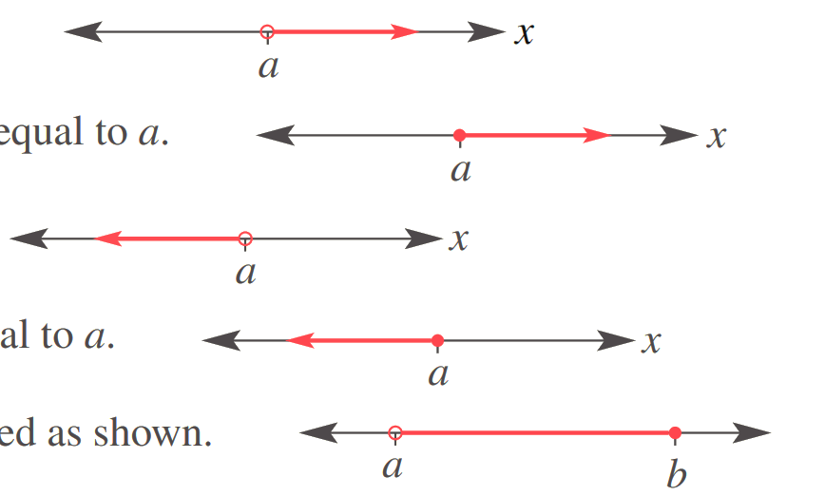  More than
$$x<a$$ | $$x>a$$
Less than or equal to | More than or equal to
$$x≤a$$ | $$x≥a$$

- Identify Inequality on a number line
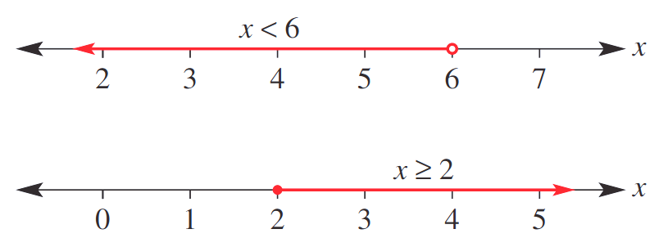  $$x<6$$ | $$x≥2$$
Identify the inequality shown.
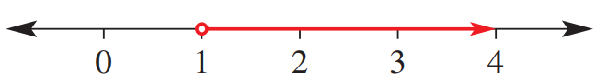 | 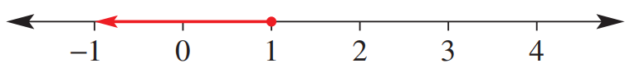
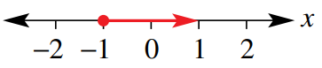
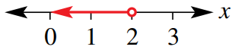

- Solving Inequalities
- Inequalities have infinite solutions.
For example, $x>3$ could be $x=3.1, 4, 792$, but not $3$, $2$ or $-4$.
- When we solve an inequality, we solve for the solution set.

- Solve inequalities the same way as equations: apply inverse operations to both sides.
- Isolate the pronumeral.
- Write the pronumeral on the LHS.
If you swap LHS and RHS, flip the inequality symbol.

- Example Solve inequalities involving positive coefficients
$y+1>10$1. Isolate $-1= -1$ $y>9$  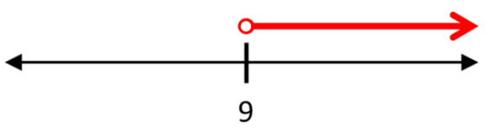 | $-1≤2a-3$  1. Isolate $+3= +3$ $2≤2a$  $1≤a$  2. LHS $a≥1$  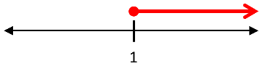

- Guided Practice
Solve these inequalities and graph the solution set.
- $x+5<8$  $-5 -5$  $x<$ ……  $$x<3$$ | - $-12+m<-7$  $$m<5$$ | - $3m-7<11$  $$m<6$$
- $4+3x>-8$  $$x>-4$$ | - $\frac{x}{2}$ $-5≤3$  $$x≤16$$ | - $\frac{2x-3}{5}$ $>9$  $$x>24$$

- Example Solve inequalities involving negative coefficients
Solve these inequalities
$-x≤-9$  $÷-1= ÷-1$  $x≥9$  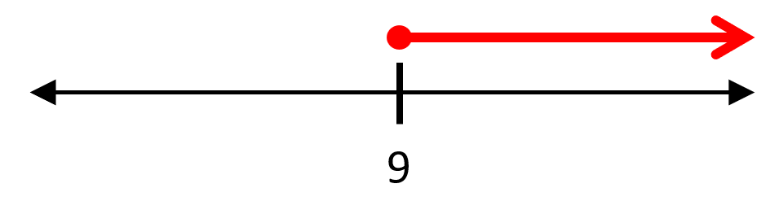 | $$5-2x>3 \\ -5= -5 \\ -2x>-2 \\ ÷-2= ÷-2$$ $x<1$  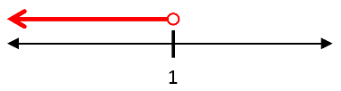

- Guided Practice
Solve these inequalities.
- $-x>15$  $÷-1 ÷-1$  $x$ … ……  $$x<-15$$ | - $-3x≤-12$  $$x≥4$$ | - $4-x<16$  $$x>-12$$
- $51>-7x$  $$x>-\frac{51}{7}$$ | - $12≥15-x$  $$x≥3$$ | - $5-$ $\frac{x}{4}$ $<13$  $$x>-32$$

Rearranging Formulas

- Rearranging Formulas
- Rearranging a formula means to change the subject to another pronumeral.
- Isolate the pronumeral by applying inverse operations to both sides.
- Remember that the subject is always on the LHS.

- Example Rearrange formulas (basic operations, one step)
Make $n$ the subject.
$$I=Prn \\ ÷Pr=÷Pr \\ \frac{I}{Pr}=n \\ n=\frac{I}{Pr}$$

- Guided Practice
Rearrange to make $x$ the subject.
- $y=x+k$  $$x=y-k$$ | - $y=x-q$  $$x=y+q$$ | - $y=x+\sqrt{rs}$  $$x=y-\sqrt{rs}$$
- $y=ax$  $$x=\frac{y}{a}$$ | - $y=$ $\frac{x}{abc}$  $$x=abcy$$ | - $y=$ $\frac{x}{\sqrt{z}}$  $$x=y\sqrt{z}$$

- Example Rearrange formulas (basic operations, two steps)
Make $x$ the subject.
$$y=4x-c \\ +c=+c \\ y+c=4x \\ ÷4=÷4 \\ \frac{y+c}{4}=x \\ x=\frac{y+c}{4}$$

- Guided Practice
Rearrange to make $x$ the subject.
- $y=5x+7$  $$x=\frac{y-7}{5}$$ | - $ab=$ $\frac{x}{2}$ $+y$  $$x=2\left(ab-y\right)$$ | - $P=2x+5y$  $$x=\frac{P-5y}{2}$$

- Example Rearrange Formulas (powers & roots)
Worked Example | Your Turn
Make $r$ the subject.  $$A=πr^{2} \\ ÷π=÷π \\ \frac{A}{π}=r^{2} \\ \sqrt{}=\sqrt{} \\ ±\sqrt{\frac{A}{π}}=r \\ r=±\sqrt{\frac{A}{π}}$$ | Make $v$ the subject.  $$a=\frac{v^{2}}{r}$$  $$v=±\sqrt{ar}$$
Make $M$ the subject.  $$v=\sqrt{\frac{2GM}{r}} \\ □^{2}=□^{2} \\ v^{2}=\frac{2GM}{r} \\ ×r=×r \\ rv^{2}=2GM \\ ÷2G=÷2G \\ \frac{rv^{2}}{2G}=M \\ M=\frac{rv^{2}}{2G}$$ | Make $r$ the subject  $$v=\sqrt{\frac{rF}{m}}$$  $$r=\frac{mv^{2}}{F}$$

- Rearranging Formulas with Subject in the Denominator
- To remove the subject from the denominator, either:
- Multiply both sides by the denominator OR
- If fraction = fraction
  - Take the reciprocal (flip) of both sides
  - Cross multiply
- If multiplying by a binomial denominator, you must multiply every term.

- Example Rearrange formulas (subject in denominator)
Worked Example | Your Turn
Make $x$ the subject.  $$y=\frac{6}{x}$$  $$×x ×x$$  $$xy=6$$  $$÷y ÷y$$  $$x=\frac{6}{y}$$ | Make $a$ the subject:  $$\frac{3}{a}=17x$$  $$a=\frac{3}{17x}$$
Make $t$ the subject.  $$A=\frac{m}{t+1} \\ ×\left(t+1\right)=×\left(t+1\right) \\ A(t+1)=m \\ t+1=\frac{m}{A} \\ t=\frac{m}{A}-1$$ | Make $x$ the subject.  $$t^{2}=\frac{y}{x-1 }$$  $$x=\frac{y+t^{2}}{t^{2}} or x=\frac{y}{t^{2}}+1$$
Make $v$ the subject.  $$\frac{1}{f}=\frac{1}{u}+\frac{1}{v}$$  $$-\frac{1}{u} -\frac{1}{u} \\ \frac{1}{f}-\frac{1}{u}=\frac{1}{v} \\ \frac{u-f}{fu}=\frac{1}{v}$$  reciprocate both sides  $$\frac{fu}{u-f}=v$$  $$v=\frac{fu}{u-f}$$ | Make $x$ the subject.  $$\frac{2}{z}=\frac{1}{x}+\frac{1}{y}$$  $$x=\frac{zy}{2y-z}$$

- Rearranging Formulas where the Subject Appears Twice
When a subject appears twice, you will need to move them all to one side, then factorise.

- Example Rearrange formulae (subject appears twice)
Worked Example | Your Turn
Make $x$ the subject.  $ax+bx=3$  $x\left(a+b\right)=3$  $$÷(a+b) ÷(a+b)$$  $$x=\frac{3}{a+b}$$ | Make $a$ the subject.  $$ak+am=5$$  $$\frac{5}{k+m}$$
Make $x$ the subject.  $ax+2y=5y+mx$  $$-mx -mx$$  $ax-mx+2y=5y$  $$-2y -2y$$  $ax-mx=3y$  $x\left(a-m\right)=3y$  $$÷(a-m) ÷(a-m)$$  $$x=\frac{3y}{a-m}$$ | Make $a$ the subject.  $$ab+3y=7y+ak$$  $$a=\frac{4y}{b-k}$$
Make $x$ the subject.  $$y=\frac{x+1}{x+2}$$  $$×(x+2) ×(x+2)$$  $$y\left(x+2\right)=x+1$$  $$xy+2y=x+1$$  $$-x -x$$  $xy-x+2y=1$  $$-2y -2y$$  $$xy-x=1-2y$$  $$x(y-1)=1-2y$$  $$÷(y-1) ÷(y-1)$$  $$x=\frac{1-2y}{y-1}$$ | Make $x$ the subject.  $$y=\frac{2x+5}{x-1}$$  $$x=\frac{y+5}{y-2}$$

Simultaneous Equations

- Investigation Simultaneous solution
- Consider $y=x+1$.
What values of $x$ and $y$ satisfy this equation?
$$x$$
$$y$$

- Consider $y=-x+5$.
What values of $x$ and $y$ satisfy this equation?
$$x$$
$$y$$

- What are the values of $x$ and $y$ that will satisfy both equations at the same time?

If we graph both linear equations on the same axis,
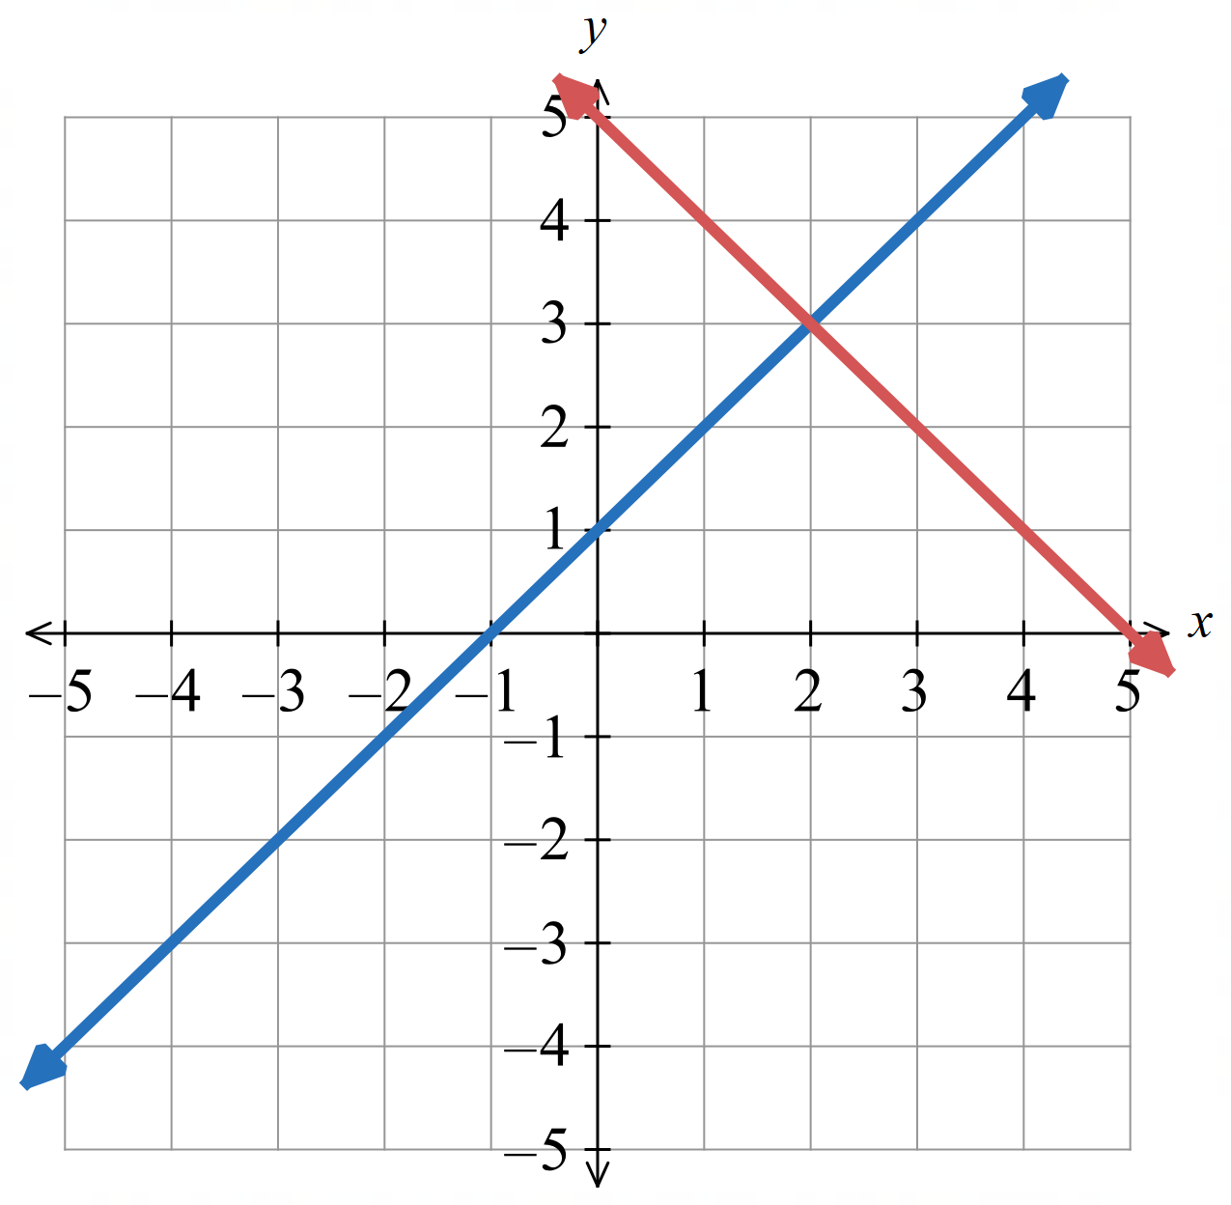
the coordinates of the point of intersection
satisfy both equations at the same time.
$x=2$, $y=3$

- Identifying the Simultaneous Solution
Solving equations simultaneously means finding the $x$ and $y$ values that make two equations true at the same time.
The $x$ and $y$ coordinates where the two lines meet solves both equations.
To find the simultaneous solution:
- Identify point of intersection.
- State the $x$ and $y$ values at the point of intersection.

- Identify simultaneous solution
- Find the values of $x$ and $y$ that solve $y=6-3x$ and $y=2x+1$ simultaneously  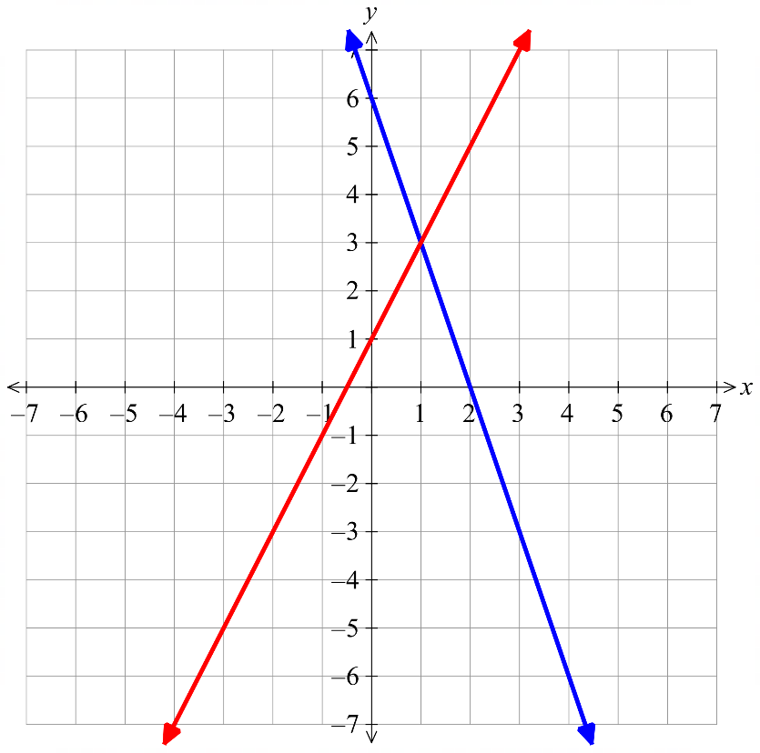  $$\left(1,3\right)$$  $$y=6-3x$$  $$y=2x+1$$  The point of intersection is: …………  The solution to both equations is:  $x=$ ………… $y=$ ……… | 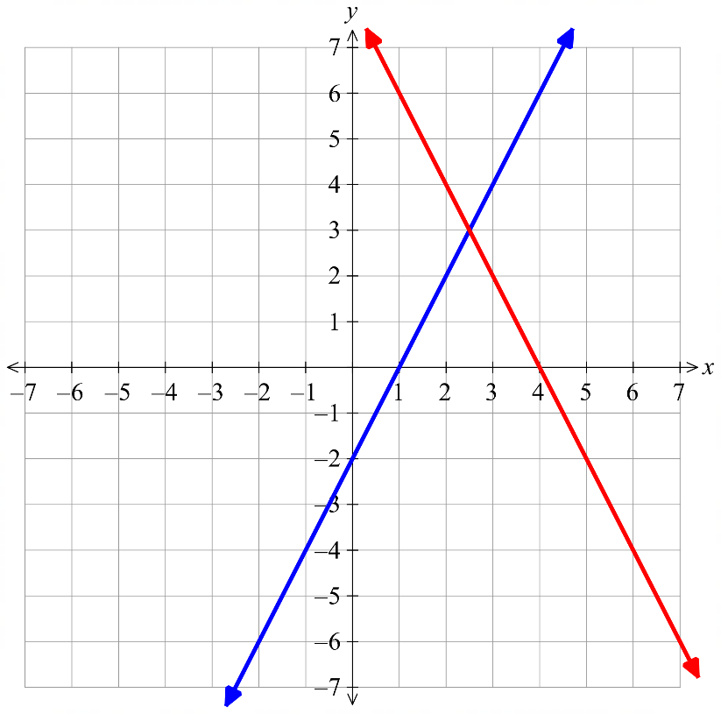  - Find the values of $x$ and $y$ that solve  $y=2x-2$ and $y=8-2x$ simultaneously  $$y=2x-2$$  $$y=8-2x$$  The point of intersection is: …………  The solution to both equations is:  $x=$ ………… $y=$ ………

- Solving Simultaneous Equations Graphically
To solve two equations simultaneously:
- Construct table of values from each equation.
- Graph each line from the table of values.
- Identify point of intersection.

- Your graphs must be accurate. You cannot do a rough sketch.

- Example Solve simultaneous equations graphically
Solve these equations simultaneously: $y=2x+1$ and $y=4-x$
1. $y=2x+1$ | $y=4-x$
  $$x$$ | 0 | $$1$$ | 2 | 3
  $$y$$ | 1 | 3 | 5 | 7
  $$x$$ | 0 | $$1$$ | 2 | 3
  $$y$$ | 4 | 3 | 2 | 1
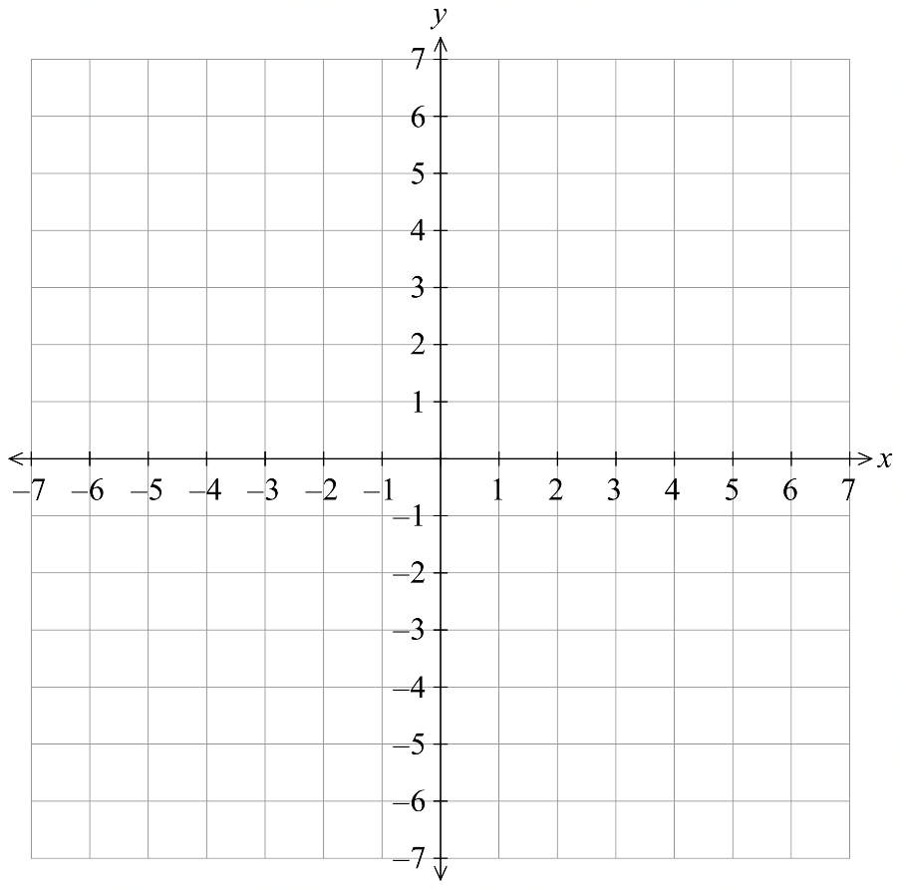  2. | 3.  The point of intersection is: $(1,3)$  The solution to both equations is:  $x=1, y=3$

- Guided Practice
Solve these equations simultaneously: $y=x+2$ and $y=2x-1$
1. $y=x+2$ | $y=2x-1$
  $$x$$ | 0 | $$1$$ | 2 | 3
  $$y$$
  $$x$$ | 0 | $$1$$ | 2 | 3
  $$y$$
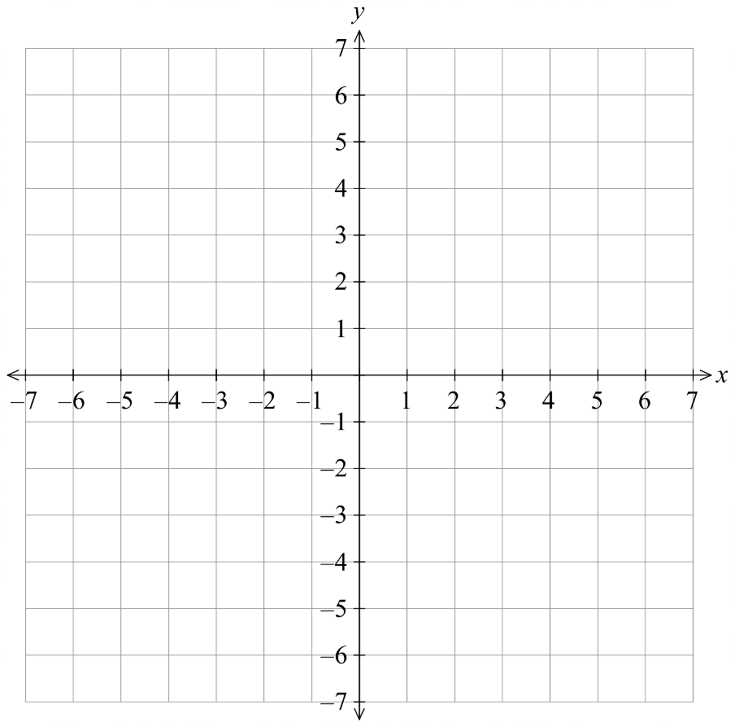  2. | 3.  The point of intersection is: …………  The solution to both equations is:  ………………………  $$x=3, y=5$$
Solve these equations simultaneously: $y=1-2x$ and $y=$ $\frac{x}{2}$ $+6$
1. $y=1-2x$ | $y=$ $\frac{x}{2}$ $+6$
  $$x$$ | 0 | $$1$$ | 2 | 3
  $$y$$
  $$x$$ | 0 | $$1$$ | 2 | 3
  $$y$$
2. | 3.  The point of intersection is: …………  The solution to both equations is:  ………………………  $$x=-2,y=5$$

- Solving Simultaneous Equations by Substitution
The goal is to form an equation with only one pronumeral, solve it, then use that value to find the other.
- Substitute into the other equation.
- Solve for the pronumeral.
- Substitute the solution back into either equation to find the other pronumeral.

- Label each equation so you can track which equation you are substituting into.

- Example Solve simultaneous equations by substitution
$y=2x+3$ (1)
$y=-x$ (2)
1. Sub (2) into (1)  $$-x=2x+3$$2. $-3x=3$  $x=-1$ | 3. Sub $x=-1$ into (2)  $y=-\left(-1\right)$  $=1$  $∴x=-1, y=1$

- Guided Practice
$y=2x$ (1)
$y=3x-5$ (2)

$$x=5,y=10$$
$2x-3y=-8$ (1)
$x=y-3$ (2)

$$x=-1, y=2$$
$y=1-2x$ (1)
$2y=x+14$ (2)

$$x=-\frac{12}{5},y=\frac{29}{5}$$
- Solving Simultaneous Equations by Substitution
- Rearrange one equation to make $x$ or $y$ the subject.
Choose the equation that avoids fractions.
- Substitute into the other equation.
- Solve for the pronumeral.
- Substitute the solution back into either equation to find the other pronumeral.

- Label each equation so you can track which equation you are substituting into.

- Example Solve simultaneous equations by substitution
$3x-2y=29$ (1)
$4x+y=24$ (2)
0. Rearrange (2) for $y$  $y=24-4x$ (3)  1. Sub $(3)$ into (1)  $3x-2\left(24-4x\right)=29$  2. $3x-48+8x=29$  $11x=77$  $x=7$ | 3. Sub $x=7$ into (3)  $y=24-4\left(7\right)$  $=-4$  $∴x=7, y=-4$

- Guided Practice
$2x+2y=14$ (1)
$y-x=3$ (2)

$$x=2,y=5$$
$3y=9x$ (1)
$2y=4x+5$ (2)

$$x=\frac{5}{2}, y=\frac{15}{2}$$
- Solving Simultaneous Equations by Elimination (No Adjustment)
The goal is to form an equation with only one pronumeral, solve it, then use that value to find the other.
- Add or subtract the equations to eliminate one of the variables.
- Solve for the pronumeral.
- Substitute the solution back into either equation to find the other pronumeral.

- Example Solve simultaneous equations by elimination (No Adjustment)
$-6x+2y=2$ (1)
$5x+2y=13$ (2)
1. $(1)-(2)$:  $$2y-6x=2 \\ - (2y+5x=13)$$  _____________________________________  $-11x=-11$  2. $x=1$ | 3. Sub $x=1$ into (1)  $2y-3\left(1\right)=1$  $y-3=1$  $y=4$  $$∴x=1,y=4$$

- Guided Practice
$x+y=6$ (1)
$3x-y=10$ (2)

$$x=4,y=2$$
$x-y=-2$ (1)
$x+y=4$ (2)

$$x=1,y=3$$
$2x+3y=-14$ (1)
$x+3y=-4$ (2)

$$x=-10, y=2$$
- Solve Simultaneous Equations by Elimination (With Adjustment)
- Multiply one or both equations so that one variable has coefficients of equal magnitude.
- Add or subtract the equations to eliminate one variable.
- Solve for the remaining variable.
- Substitute the solution into either original equation to find the other variable.

- Example Solve simultaneous equations by elimination (with adjustment)
$3x-2y=29$ (1)
$4x+5y=8$ (2)
1. $\left(1\right)×4→12x-8y=116$ (3)  $\left(2\right)×3→12x+15y=24$ (4)  2. $\left(3\right)-\left(4\right):$  $$12x+15y=24 \\ - (12x-8y=116)$$  ________________________________________  $$23y=-92$$  3. $y=-4$ | 4. Sub $y=-4$ into $\left(1\right)$  $$3x-2\left(-4\right)=29$$  $$3x+8=29$$  $$3x=21$$  $$x=7$$  $∴x=7, y=-4$

- Guided Practice
$3x+2y=7$ (1)
$5x+y=7$ (2)

$$x=1, y=2$$
$15x+2y=27$ (1)
$3x+7y=45$ (2)

$$x=1,y=6$$
$3x+5y=22$ (1)
$2x+7y=33$ (2)

$$x=-1,y=5$$

Equating Coefficients

- Equating Coefficients
Equating coefficients is a problem-solving strategy.
1. Expand out any brackets
2. Identify and set equal the coefficients of matching variables on both sides of an equation.
3. Find the value of the unknowns. You may need to use simultaneous equations.

- Example Find an unknown by equating coefficients
Given $a{\left(x+3\right)}^{2}-bx+5=4x^{2}+c$, Find $a,b,c$.
1. $a\left(x^{2}+6x+9\right)-bx+5=4x^{2}+c$  $$ax^{2}+6ax+9a-bx+5=4x^{2}+c$$  2. ¯ ¯¯ ¯¯ ¯¯¯ ¯¯¯ ¯ ¯  coefficients of $x^{2}$: $a=4$  coefficients of $x$: $6a-b=0$  constant terms: $9a+5=c$ | 3. Solve for unknowns  Substitute $a=4$ into two other equations.  $6\left(4\right)-b=0$, $b=24$  $9\left(4\right)+5=c$, $c=41$  $$a=4,b=24,c=41$$

- Guided Practice
Given that $(x+a)(x+b)=x^{2}+7x+12$, find $a$ and $b$.

$a=3, b=4$ or other way around
Find $a$, $b$, $c$ such that $ax\left(x+1\right)+bx+c=2x^{2}+x-3$.

$a=2, b=-1, c=-3$

Foundation
- Find the missing values by equating coefficients.
- $a\left(2x+7\right)=8x+14b$  $$a=4, b=2$$ | - $\left(c-2\right)x^{2}+3d=7x^{2}+9$  $$c=9, d=3$$
- $9\left(2x+5\right)+2\left(3x+b\right)=ax+23$  $$a=24, b=-11$$ | - $4\left(2x+b\right)+a\left(x+3\right)=10x+2$  $$a=2,b=-1$$
- $4\left(3x+2\right)+a\left(x+b\right)=15x-16$  $$a=3, b=-8$$ | - $2ax+9-3\left(x+b\right)=5x-30$  $$a=4,b=13$$

- Find the missing values by equating coefficients.
  - $\left(x+4\right)\left(x-6\right)+ax+b=x^{2}+8x-25$

$$a=10, b=-1$$
  - $\left(2x-5\right)\left(2x-7\right)+ax^{2}+b=3x^{2}-24x+12$

$$a=-1,b=-23$$
  - ${\left(x-2\right)}^{2}+x+a\left(x+b\right)=x^{2}+1$

$$a=3,b=-1$$
  - ${\left(x+b\right)}^{2}=x^{2}+cx+49$

$$if b=7, c=14 | if b=-7, c=-14$$
  - $\left(x+2c\right)\left(x+c\right)=x^{2}+dx+50$

$$if c=5, d=15 | if c=-5, d=-15$$

Development
- A parabola has the equation $y=x^{2}+2x+3$.
Find the values of $a$ and $c$ in the equation $y={\left(x-a\right)}^{2}+c$ and hence determine the coordinates of the vertex.

$$\left(-1, 2\right)$$
- A rectangular prism has width $y$ cm, length $(x+a)$ cm and height $(x+b)$ cm,
where a and b are integers and $a>b$.
  - Show that the surface area of the rectangular prism is given by the expression
$2y\left(2x+a+b\right)+2(x+a)(x+b)$ cm²

  - If the surface area of the rectangular prism is equivalent to the expression $2y\left(2x+1\right)+2x^{2}+2x-12$ cm², find $a$ and $b$.

$$a=3,b=-2$$
- Find the value of $m$.
$$\left(x+3\right)\left(m-2\right)=-\frac{x}{3}-1$$

$$m=\frac{5}{3}$$

Mastery
- Write $\frac{x+3}{x+5}$ in the form $a+$ $\frac{b}{x+5}$.

$$1-\frac{2}{x+5}$$
- Write $3x^{2}+18x-5$ in the form $\frac{{\left(x-a\right)}^{2}+c}{b}$.

$$\frac{{\left(x+3\right)}^{2}-\frac{32}{3}}{\left(\frac{1}{3}\right)}$$
- Write $x^{2}+4x+y^{2}-2y$ in the form ${\left(x+a\right)}^{2}+{\left(y+b\right)}^{2}+c$.

$${\left(x-2\right)}^{2}+{\left(y+1\right)}^{2}-5$$
- $5x^{2}+px-8=q{\left(x-1\right)}^{2}+r$. Find $p,q,r$.

$$p=-10, q=5, r=-13$$

- Find the missing values by equating coefficients.
  - $4x^{3}+\left(x+a\right)\left(x+b\right)+cx=ax^{3}-3x^{3}+x^{2}-x-42$

$$a=7, b=-6, c=-2$$
  - $\left(ax+1\right)\left(x+5\right)\left(x+b\right)=2x^{3}+23x^{2}+71x+30$

$$a=2,b=6$$
  - ${\left(x+a\right)}^{2}\left(x-2\right)=x^{3}+bx^{2}-3x-18$

$$a=3,b=4$$
  - When expanded, the term for $x^{2}$ in $\left(x+4\right)\left(x+c\right)\left(2x-1\right)$ has a coefficient of $-9$.
What is the value of $c$?

$$c=-8$$

Splitting the Numerator

- Splitting the Numerator
Splitting the numerator is a technique for rewriting an algebraic fraction into an integer and a simpler fraction.
$$\frac{px+q}{x+r}=a+\frac{b}{x+r}$$

We can do this by equating coefficients or by rewriting the numerator so part of it cancels with the denominator.
This is an important skill for sketching hyperbolas later on.

- Example Split the numerator
Write $\frac{x+3}{x+5}$ in the form $a+$ $\frac{b}{x+5}$
Equating Coefficients:  $$\frac{x+3}{x+5}=a+\frac{b}{x+5} \\ x+3=a\left(x+5\right)+b \\ x+3=ax+5a+b$$  $$a=1 \\ 5a+b=3 \\ ∴b=-2$$  $$\frac{x+3}{x+5}=1-\frac{2}{x+5}$$ | Rewriting Numerator  $$\frac{x+3}{x+5}=\frac{x+5-5+3}{x+5} \\ =\frac{x+5}{x+5}+\frac{-5+3}{x+5} \\ =1-\frac{2}{x+5}$$

- Guided Practice
Write in the form $a+$ $\frac{b}{x+r}$
$$\frac{x+1}{x+5}$$  $$1-\frac{4}{x+5}$$ | $$\frac{2x+3}{x+5}$$  $$2-\frac{7}{x+5}$$

Foundation
- Write in the form $a+$ $\frac{b}{x+r}$
- $\frac{x+4}{x+1}$  $$1+\frac{3}{x+1}$$ | - $\frac{x+9}{x+5}$  $$1+\frac{4}{x+5}$$
- $\frac{x+2}{x+6}$  $$1-\frac{4}{x+6}$$ | - $\frac{x+1}{x+4}$  $$1-\frac{3}{x+4}$$
- $\frac{2x+7}{x+3}$  $$2+\frac{1}{x+3}$$ | - $\frac{3x+10}{x+4}$  $$3-\frac{2}{x+4}$$
- $\frac{2x+3}{x+5}$  $$2-\frac{7}{x+5}$$ | - $\frac{x+5}{x-2}$  $$1+\frac{7}{x-2}$$
- $\frac{2x+3}{x-1}$  $$2+\frac{5}{x-1}$$ | - $\frac{4x+9}{2x+1}$  $$2+\frac{7}{2x+1}$$
- $\frac{6x+5}{3x-1}$  $$2+\frac{7}{3x-1}$$ | - $\frac{5-x}{x+3}$  $$-1+\frac{8}{x+3}$$

Quadratic Equations

- Null Factor Law
The null factor law says that if two factors multiply to zero, one or both factors must be zero.
If $a×b=0$  Then $a=0$ or $b=0$ | If $\left(ax+b\right)\left(cx+d\right)=0$  Then $ax+b=0 or cx+d=0$  $$x=-\frac{b}{a} or x=-\frac{d}{c}$$

- Identify Solution using null-factor law
- $x\left(x-5\right)=0$ | - $\left(x-5\right)\left(x-2\right)=0$ | - $(2x-5)(x-2)=0$
- $(2x+5)(x-2)=0$ | - $10\left(2x+5\right)\left(x-2\right)=0$ | - $\left(2x+5\right)\left(7x-1\right)=0$
- $\left(x-a+b\right)\left(x-2\right)=0$ | - $\left(x+a-b\right)\left(x-2\right)=0$ | - Explain why we cannot use the null factor law:  $$\left(x-5\right)\left(x-2\right)=9$$

- Solve Quadratic Binomial Equations
- To solve binomial equations:
- Write equation in the form $ax^{2}+bx=0$, if it isn’t already.
- Factorise the expression.
- Use the null factor law to solve for $x$.

- Example Solve quadratic equations of the form ax^2+bx=0
$y^{2}-7y=0$  2. $y\left(y-7\right)=0$  3. $y=0 or y-7=0$  $y=0 y=7$ | $x^{2}=36x$  1. $x^{2}-36x=0$  2. $x(x-36)=0$  3. $x=0 or x-36=0$  $x=0 x=36$

- Guided Practice
Solve these quadratic equations.
- $x^{2}-5x=0$  $x\left(x-5\right)=0$  $$x=0 or 5$$ | - $x^{2}+4x=0$  $$x=0 or-4$$ | - $2x^{2}=8x$  $$x=0 or 4$$
- $x^{2}=16$  $$x=-4 or 4$$ | - $x^{2}+16=0$  no real solution | - $3x^{2}=18x$  $$x=0 or 6$$

- Solving Monic Quadratic Trinomial Equations
- To solve quadratic equations that are monic quadratic trinomials:
- Write equation in the form $x^{2}+bx+c=0$, if it isn’t already.
- Factorise the expression using the PSF method.
- Use null factor law to solve for $x$.

- Example Solve quadratic equations of the form x^2+bx+c=0
$x^{2}+x-6=0$  2. $\left(x+3\right)\left(x-2\right)=0$  3. $x=-3 or 2$ | $x^{2}-13x=-36$  1. $x^{2}-13x+36=0$  2. $\left(x-4\right)\left(x-9\right)=0$  3. $x=4 or 9$

- Guided Practice
Solve for $x$.
- $x^{2}+4x+3=0$  $\left(x+3\right)\left(x+1\right)=0$  $x=$ … or …  $$x=-3 or-1$$ | - $x^{2}-7x+10=0$  $$x=5 or 2$$ | - $x^{2}=x+6$  $$x=3 or-2$$
- $x^{2}-8x+16=0$  $$x=4$$ | - $x^{2}+4x=5$  $$x=-5 or 1$$ | - $x^{2}+x=30$  $$x=5 or-6$$

- Solving Non-Monic Quadratic Equations
To solve quadratic equations that are non-monic quadratic trinomials:
- Write equation in the form $x^{2}+bx+c=0$, if it isn’t already.
- Factorise the LHS using PSF.
- Use null-factor law to solve for $x$.

- Example Solve non-monic quadratic equations by factorising
$2x^{2}+11x+12=0$ | $$10x^{2}-13x=3$$
  2. $2x^{2}+3x+8x+12=0$  $x\left(2x+3\right)+4\left(2x+3\right)=0$  $\left(x+4\right)\left(2x+3\right)=0$  3.  $$x=-4 x=-\frac{3}{2}$$ | P: $24$  S: $11$  F: $3,8$
  1. $10x^{2}-13x-3=0$  2. $10x^{2}-15x+2x-3=0$  $5x\left(2x-3\right)+\left(2x-3\right)=0$  $\left(5x+1\right)\left(2x-3\right)=0$  3.  $$x=-\frac{1}{5} x=\frac{3}{2}$$ | P: $-30$  S: $-13$  F: $-15,2$

- Guided Practice
Solve for $x$.
- $4x^{2}+16x+7=0$  P: 28  S: 16  F: ………  $$x=-\frac{7}{2} or-\frac{1}{2}$$ | - $2x^{2}-17x+35=5$  P: ………  S: ………  F: ………  $$x=6 or \frac{5}{2}$$
- $2x^{2}-23x+11=0$  $$x=11 or\frac{1}{2}$$ | - $18x^{2}+12x=16$  $$x=\frac{2}{3} or-\frac{4}{3}$$

Completing the Square

- Interpret completing the square
Consider the quadratic equation $x^{2}-2x-5=0$. Try to factorise it.
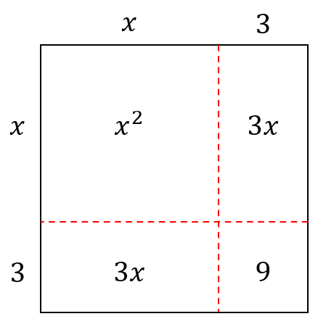
Some quadratic equations cannot be factorised easily.
We can solve them by completing the square.

Consider the area model of perfect square ${\left(x+3\right)}^{2}$.
It is a …………… with sides of ……………

Using these diagrams, make a perfect square by finding the missing number.
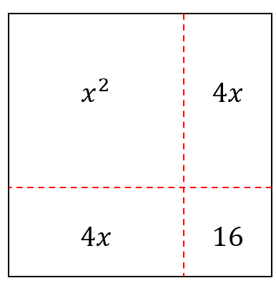  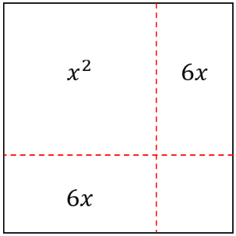  $x^{2}+8x+ 16$ $={\left( \right)}^{2}$ | $x^{2}+12x+$ ……… $={\left( \right)}^{2}$
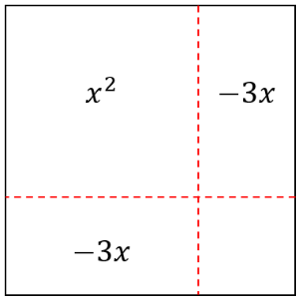  $x^{2}-6x+$ …… $={\left( \right)}^{2}$ | 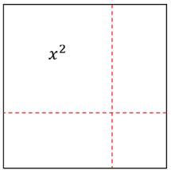  $x^{2}+24x+$ ……… $={\left( \right)}^{2}$
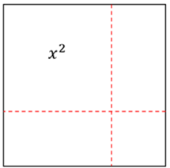  $x^{2}+10x+$ …… $={\left( \right)}^{2}$ | $x^{2}-2x+$ ……… $={\left( \right)}^{2}$

- Writing in the form ${\left(x+a\right)}^{2}+c$
We can write any quadratic expression in the form ${\left(x+a\right)}^{2}+c$ by completing the square.
A perfect square is of the form $x^{2}+2ax+a^{2}={\left(x+a\right)}^{2}$
- Halve the coefficient of $x$. This is $a.$
- Add and subtract $a^{2}$ from the original expression; this keeps it the same.
- Factorise the expression ${\left(x+a\right)}^{2}$ by recognising the perfect square.

- Example Write a quadratic expression in the form ${\left(x+a\right)}^{2}+c$
$$x^{2}+8x-1$$  1. $a=4$  2. $x^{2}+8x+4^{2}-4^{2}-1$  ¯¯¯¯¯¯¯¯¯  3. ${\left(x+4\right)}^{2}-17$  $$∴x^{2}+8x-1={\left(x+4\right)}^{2}-17$$ | $$x^{2}+5x+2$$  1. $a=$ $\frac{5}{2}$  2. $x^{2}+5x+{\left(\frac{5}{2}\right)}^{2}-{\left(\frac{5}{2}\right)}^{2}+2$  ¯¯¯¯¯¯¯¯¯¯  3. ${\left(x+\frac{5}{2}\right)}^{2}-\frac{17}{4}$  $$∴x^{2}+5x+2={\left(x+\frac{5}{2}\right)}^{2}-\frac{17}{4}$$

- Guided Practice
Write these expressions in the form ${\left(x+a\right)}^{2}+c$
- $x^{2}+6x+3$  1. $a=$ ……  2. $x^{2}+6x+$ …… $-$ …… $+3$  3. | - $x^{2}-8x+5$
- $x^{2}+7x$ | - $x^{2}-9x-11$

- Solving Quadratic Equations by Completing the Square
When we can’t use the PSF method to factorise a quadratic, we can solve a quadratic equation by completing the square.
1. Write the quadratic in the form ${\left(x+a\right)}^{2}+c$ by completing the square.
2. Solve by isolating ${\left(x+a\right)}^{2}.$
- Remember that a quadratic equation can have no real solution.

- Example Solve quadratic equations by completing the square
$$x^{2}+8x=20$$  1. $+4^{2} +4^{2}$  $x^{2}+8x+16=36$  2. ${\left(x+4\right)}^{2}=36$  3. $x+4=±6$  $x=-4±6$  $=-10 or 2$ | $x^{2}-6x+2=0$  1. $+{(-3)}^{2} +{(-3)}^{2}$  $x^{2}-6x+9+2=9$  2. ${\left(x-3\right)}^{2}+2=9$  3. ${\left(x-3\right)}^{2}=7$  $x-3=±\sqrt{7}$  $x=3±\sqrt{7}$  $=3+\sqrt{7}$ or $3-\sqrt{7}$  $≈5.65$ or $0.35$

- Guided Practice
Solve these equations by completing the square
- $x^{2}-6x+1=0$  $$x=3±2\sqrt{2}$$ | - $x^{2}+4x+1=0$  $$x=-2±\sqrt{3}$$
- $x^{2}-7x+10=0$  $$x=5 or 2$$ | - $2x^{2}-12x-22=0$  $$x=3±2\sqrt{5}$$

Quadratic Formula and Discriminant

- The Quadratic Formula
For $ax^{2}+bx+c=0$:
$$x=\frac{-b±\sqrt{b^{2}-4ac}}{2a}$$

- Rearrange equation to $ax^{2}+bx+c=0$, if not already.
- Identify $a,b,c$
- Substitute into formula.
- Simplify; do not put into calculator (we usually want the surd in exact form).

- Example Solve quadratic equations using the quadratic formula
$$x^{2}-x-2=0$$  2. $a=1, b=-1, c=-2$  3. $x=$ $\frac{-\left(-1\right)±\sqrt{{\left(-1\right)}^{2}-4\left(1\right)\left(-2\right)}}{2\left(1\right)}$  4. $=$ $\frac{1±\sqrt{9}}{2}$  $$=\frac{1±3}{2}$$  $=2$ or $-1$ | $2y^{2}-9y=-3$  1. $2y^{2}-9y+3=0$  2. $a=2, b=-9, c=3$  3. $y=$ $\frac{-\left(-9\right)±\sqrt{{\left(-9\right)}^{2}-4\left(2\right)\left(3\right)}}{2\left(2\right)}$  4. $=$ $\frac{9±\sqrt{57}}{4}$

- Guided Practice
Solve using the quadratic formula.
- $x^{2}+6x+2=0$  $$x=-3±\sqrt{7}$$ | - $2x^{2}-x-1=0$  $x=1$ or $-\frac{1}{2}$
- $x^{2}+x=4$  $$\frac{-1±\sqrt{17}}{2}$$ | - $16x^{2}+48x=-4$  $$\frac{-3±2\sqrt{2}}{2}$$

- The Discriminant
The discriminant $Δ=b^{2}-4ac$ is the part of the quadratic formula inside the square root.
$$x=\frac{-b±\sqrt{Δ}}{2a}$$
The value of the discriminant tells us how many solutions a quadratic equation has.
$Δ<0$ no real solutions
$Δ=0$ one solution
$Δ>0$ two solutions

- Investigation The discriminant and number of solutions
Calculate the discriminant and use it to confirm the number of solutions by solving the quadratic equation.
$$x^{2}+6x+5=0$$  $$Δ=$$  There are ………… solutions.  Solving: | $$x^{2}+6x+9=0$$  $$Δ=$$  There are ………… solutions.  Solving: | $$x^{2}+6x+100=0$$  $$Δ=$$  There are ………… solutions.  Solving:

- The Discriminant
For $ax^{2}+bx+c=0$:
$$Δ=b^{2}-4ac$$

The value of the discriminant tells us how many solutions a quadratic equation has.
$Δ<0$ no real solutions
$Δ=0$ one solution
$Δ>0$ two solutions

- Example Apply discriminant to solve problems involving number of solutions
Find the values of $k$ for which $x^{2}+8x+k=0$ has two solutions.
$$a=1, b=8, c=k$$
$$Δ=8^{2}-4\left(1\right)\left(k\right)=64-4k$$
$$Δ>0$$
$$∴64-4k>0 \\ -4k>-64 \\ k<16$$

- Guided Practice
- Find the values of $k$ for which $x^{2}+8x+k=0$ has no real solutions.

$$k>16$$
- Find the values of $k$ for which $x^{2}+k=10x$ has two real solutions.

$$k<25$$
- Find the values of $k$ for which $2x^{2}+4x+k$ has exactly one real solution.

$$k=2$$
- Real or Rational Roots
$Δ<0$ no real solutions
$Δ=0$ one real equal solution
$Δ>0$ two real distinct solutions
If $Δ$ is a perfect square, the solutions will be rational i.e., can be written without a square root.
Perfect squares are : 0, 1, 4, 9, 16, 25, 36, 49, 64, 81, 100, 121, 144, 169, etc.

- Interpret value of the discriminant
The discriminant of a quadratic equation is given.
Decide whether the solutions will be real, not real, rational, or irrational.
- $Δ=15$ | - $Δ=-36$ | - $Δ=0$
  - Real  - Distinct  - Rational | - Not real  - Equal  - Irrational
  - Real  - Distinct  - Rational | - Not real  - Equal  - Irrational
  - Real  - Distinct  - Rational | - Not real  - Equal  - Irrational
- $Δ=31$ | - $Δ=-25$ | - $Δ=16$
  - Real  - Distinct  - Rational | - Not real  - Equal  - Irrational
  - Real  - Distinct  - Rational | - Not real  - Equal  - Irrational
  - Real  - Distinct  - Rational | - Not real  - Equal  - Irrational
- $Δ=-139$ | - $Δ=1$ | - $Δ=169$
  - Real  - Distinct  - Rational | - Not real  - Equal  - Irrational
  - Real  - Distinct  - Rational | - Not real  - Equal  - Irrational
  - Real  - Distinct  - Rational | - Not real  - Equal  - Irrational

- Example Apply discriminant to solve problems involving rationality of solutions
Show that $x^{2}+\left(k+1\right)x+k=0$ has rational solutions for all rational values of $k.$
$$a=1, b=k+1, c=k$$
$$Δ={\left(k+1\right)}^{2}-4\left(1\right)\left(k\right)$$
$$=k^{2}+2k+1-4k$$
$$=k^{2}-2k+1$$
$$={\left(k-1\right)}^{2}$$
Since ${\left(k-1\right)}^{2}$ is a perfect square and $≥0$for all real $k$, the solutions are always rational.

- Guided Practice
- Show that $x^{2}+2kx+\left(k^{2}-1\right)=0$ always has rational solutions for all rational $k$.

- Show that $x^{2}+\left(k+2\right)x+\left(k+1\right)=0$ always has rational solutions for all rational $k$.

Exponential Equations

- Exponential Equations
- Exponential equations involve finding the value of a pronumeral in the index.
- For example: $2^{x}=8$ and $3^{2x}-3^{x}-6=0$.
- To solve exponential equations:
- Rewrite all terms with the smallest possible base number.
- Write an equation using the powers.

- Example Solve exponential equations
$${25}^{x}=125$$1. $5^{2x}=5^{3}$2. $2x=3$ $x=$ $\frac{3}{2}$ | $$3^{x}=\frac{1}{9}$$1. $3^{x}=$ $\frac{1}{3^{2}}$ $3^{x}=3^{-2}$2. $x=-2$

- Guided Practice
- $9^{x}=27$  $3^{}=3^{}$  $$x=\frac{3}{2}$$ | - $2^{x}=$ $\frac{1}{8}$  $$x=-3$$ | - ${16}^{x}=64$  $$x=\frac{3}{2}$$

- Example Solve exponential equations with binomial powers
$$9^{2x-1}=27$$1. ${\left(3^{2}\right)}^{2x-1}=3^{3}$ $3^{4x-2}=3^{3}$2. $4x-2=3$ $4x=5$ $x=$ $\frac{5}{4}$

- Guided Practice
- ${25}^{x+3}=125$  $$x=-\frac{3}{2}$$ | - ${27}^{x+3}=9^{2x}$  $$x=9$$

